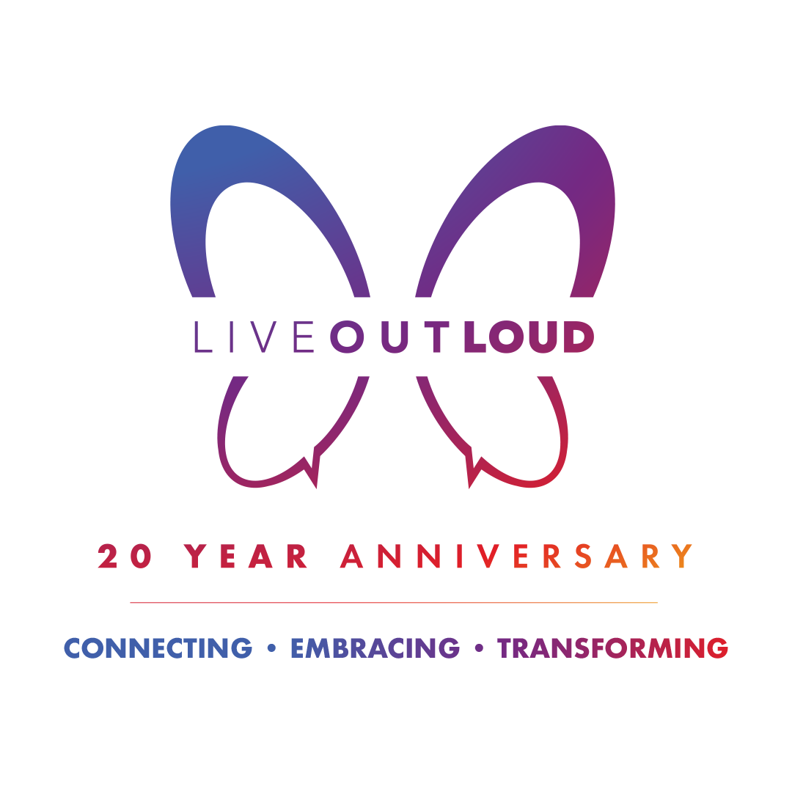
The Live Out Loud Young Trailblazers Scholarship was created to provide financial support to LGBTQ+ identifying youth with financial needs. Through this scholarship, LGBTQ+ youth can apply for funds to pay for education-related expenses to pursue a degree from an accredited college, university, or technical/vocational program.

This year, Live Out Loud is awarding scholarships of $5,000.00.

Applications are due by March 7th, 2022. Winners will be notified on April 22nd, 2022.

Application Requirements:

- The award is open only to graduating high school seniors who identify as LGBTQ+.
- Applicants must be planning to enroll in a university, college, technical/vocational school, or other post-secondary program.
- Applicants need to reside in the Tri-State area including New York, Connecticut, and New Jersey.
- Applicants must send (a) the completed application form, (b) the required essay / other formatted responses, and (c) two letters of recommendation.
- Finalists must participate in an individual virtual interview that will be scheduled during April 2022.
- Awards are given only to applicants approved by the Scholarship Committee based on the criteria above and outlined in this application.

Application Submissions:
- All applications this year should be submitted digitally, via e-mail to the Manager of Educational Programs, Martine Bowman, at Martine@liveoutloud.info.
- To submit your application digitally, download the application and complete all questions. Your completed application may be submitted as an attachment in .doc, .docx, or .pdf format, or as a Google document. The subject line of your email should appear as follows: “Preferred First and Last Name - Scholarship Application”
- Incomplete applications will not be considered.

Letters of Recommendation:
- Students must submit two letters of recommendations from academic and/or organization professionals that attest to their prior commitment to LGBTQ+ issues, or their potential to be a courageous leader in the future. Please have recommenders email their letters directly to Martine at Martine@liveoutloud.info.

Scholarship Application Form

Any information provided on this application is strictly confidential and will not be disseminated for any reason other than determining eligibility for the Live Out Loud Educational Scholarship or as required by state or federal agencies.

STUDENT INFORMATION
Preferred Name (First and Last Name):
**For legal purposes, we require your legal name in order to disburse scholarship funds to scholarship recipients. If your legal name matches your preferred name, please leave Preferred Name blank.**

Legal Name (First, Middle, and Last Name):

Preferred Pronouns (place an X on the line next to your response):
____ He/Him/His
____ She/Her/Hers
____ They/Them/Theirs
____ Other (please specify):
Full Date of Birth (please provide Month, Day, and Year):

Home Mailing Address:

House Number and Street:
Apartment:
City/State:
Zip Code:
Are we permitted to send mailings regarding our organizational name or purpose to this address? (place an X on the line next to your response)

____ Yes
____ No

Contact Information:

Phone Number:

E-mail:
Are we permitted to call and/or leave a message at the above phone number regarding our organizational name or purpose? (place an X on the line next to your response)

____ Yes
____ No (If not, we will contact you via email).
DEMOGRAPHIC INFORMATION
Do you self-identify as LGBTQ+? (place an X on the line next to your response)

___Yes
___ No
Ethnicity (place an X next to all that apply):

___ Asian
___ Black
___ Latinx
___ Middle Eastern/North African
___ White (non-Hispanic)
___ Other (please specify):
Gender Identity (place an X next to all that apply):

___ Cisgender
___ Transgender
___ Non-Binary
___ Genderqueer
___ Intersex
___ Other (please specify):

Sexuality (place an X next to all that apply):

___ Gay/Lesbian
___ Straight
___ Pansexual
___ Bisexual
___ Asexual
___ Other (please specify):
Are you a U.S. Citizen / Full Time Resident? (place an X on the line next to your response)

___ Yes
___ No
If not the United States, what is your country of birth:
HIGH SCHOOL INFORMATION
High School Name (do not abbreviate or use nicknames):

Type of High School (place an X on the line next to your response):

___ Public ___Charter ___ Private
High School Address:

Street Number and Street:
Floor (if applicable):
City/State:
Zip Code:
Do you receive financial aid from your high school? (place an X on the line next to your response)

____ Yes
____ No
____ N/A
Special program (if any):

Expected Graduation Date (please provide month and year):

GPA:

Your GPA:
Highest GPA Possible at Your School:
PARENT/GUARDIAN INFORMATION
Prefix (place an X on the line next to your response):

Mr. ___ Mrs. ___ Ms. ___ Other: ____
Name:

First Name:
Last Name:
Occupation:

Highest Level of Education (place an X on the line next to your response):

___ None
___ Some grade school
___ Grade school graduate
___ Some high school
___ High school graduate
___ Some college
___ Associate’s degree (2-year college)
___ Bachelor’s degree
___ Some graduate school
___ Graduate degree or above

Prefix (place an X on the line next to your response):

Mr. ___ Mrs. ___ Ms. ___ Other: ____
Name:

First Name:
Last Name:
Occupation:

Highest Level of Education (put an X on the line next to your response):

___ None
___ Some grade school
___ Grade school graduate
___ Some high school
___ High school graduate
___ Some college
___ Associate’s degree (2-year college)
___ Bachelor’s degree
___ Some graduate school
___ Graduate degree or above
ANTICIPATED POST-SECONDARY INFORMATION

The following information should be provided if known. If not, then the information should be provided upon being awarded the scholarship in order to facilitate the distribution of scholarship funds.
Anticipated college, university, or technical/vocational school:

Contact Person (Admissions Counselor, Academic Advisor, etc.) :

Name:
Phone:
E-mail:
School Address:

Building Name (if applicable):
Street Number and Street:
Floor (if applicable):
City/State:
Zip Code:
SHORT ANSWER QUESTIONS:
Please explain your financial need. Are there any circumstances that will impact your ability to pay for school?

How has your LGBTQ+ identity impacted your life at home, school, or in your community? What, if any, challenges have you encountered as a result of these experiences? How have you chosen to face these challenges?

Please indicate your intended academic major in college or tech/vocational school. Why are you choosing this particular area of study? What are your career goals and aspirations? If you are unsure, please describe what interests you plan to explore and why.

Please describe your most important activities and achievements, including extracurricular activities, work experience, academic honors, community service, and other volunteer opportunities.

STUDENT CERTIFICATION:
I certify that the information contained in this application is true.

Applicant’s Signature:
Date:

ESSAY / OTHER FORMATTED RESPONSES:

Part One: In a cohesive essay (500 - 1000 words approximately), please answer the following question. Feel free to get creative with your responses.

An integral part of Live Out Loud’s mission is to connect LGBTQ+ youth with role models. Who is your role model? Why do you look up to this person? How have you been a role model to someone in your school and/or community?

Part Two: Read the following question and respond to it using one of the formatting options listed below it.

How have you distinguished yourself as a leader in, or on behalf of, the LGBTQ+ community? Describe a challenge you observed and how you demonstrated leadership in response to that issue. What was your impact, and what did you learn (think about the impact of this situation on yourself, your close connections, and the community around you)?

Below are the three format options, of which you must select one, to use for your response to Part Two. Be sure to see the additional guidelines for each option which can be found on the next page of this document.

- Option 1: Artist Portfolio - Submit a creative piece, or group of pieces (film, dance recording, spoken word, music, visual art, short story, anything you can imagine that can be sent to us), that relate to your experience as an LGBTQ+ leader. Attach a 250-500 word artist statement that connects your artwork to the prompt and further explains your work.

- Option 2: Images with Captions - Find five images that demonstrate your response to the prompt and write 100-200 word captions under each image that connect the images to the question.

- Option 3: Written Essay - Write an essay between 500 and 1000 words in response to the prompt.

Guidelines for Responding to Question #1 - Essay:

- Essay should be typed with name and title and single-spaced.
- Essay should be between 500 and 1000 words.
- Final document should be a .doc, .docx, .pdf, or Google doc file with the following file name: Preferred First and Last Name_Essay 1.
- Submit the Essay as a separate file from the completed application form, but attached in the same email.

Guidelines for Responding to Question #2 - Your Choice:

Option 1: Artist Statement
- All artistic pieces included in this option must be original and created by you.
- Here are the approximate time/page limits for your work (if you go a little over it is ok):
  - Film: No more than 5 minutes total.
  - Dance Video/Choreography: no more than 5 minutes total.
  - Music: At least one song, maximum 3.
  - Visual Art: At least 2 pieces, maximum 5.
  - Short Story/Writing: No more than 5 pages.
- Artist statements should include a description of how you made the piece/pieces, what the meaning of the pieces are, and how your art demonstrates your leadership in the LGBTQ+ community. The artist statement must demonstrate how the art connects to change you’ve made, or attempted to make, in your community.
- When you are choosing the artifacts in your portfolio, try and select pieces that had a demonstrated impact on your community. This option must include artistic pieces. If you don’t have any pieces to show, but you want to talk about an art project you did, you can select essay option #3.
- Here are some guidelines for writing an artist statement if you’ve never written one before: https://thecreativeindependent.com/guides/how-to-write-an-artist-statement/
- Format for submission:
  - Submit as a PDF with the file name Last Name_First Name_Portfolio.pdf
  - Each distinct piece of art should be on a separate page.
  - The artist statement should be after all of the art pieces in the same document.
  - To make a PDF from Word, you can click “File”, “Export As…”, “PDF,” or find a free PDF converter online.
  - Submit the Portfolio as a separate file from the completed application form, but attached in the same email.
  - Ensure the artist statement is approximately between 250-500 words.

Option 2: Images with Captions
- Images can be photographs, drawings, artifacts (like certificates you earned), and/or images from the web.
- Images should relate to how you’ve demonstrated leadership in your community.
- Format for submission:
  - Submit as a PDF with the file name Preferred First and Last Name_Captions.
  - To make a PDF from Word, you can click “File”, “Export As…”, “PDF,” or find a free PDF converter online.
  - Submit this option as a separate file from the completed application form, but attached in the same email.
  - Ensure the response is approximately between 100-200 words per image or 500-1000 words total.

Option 3: Written Response
- Essay should be typed with name and title and single-spaced.
- Essay should be between 500 and 1000 words.
- Final document should be a .doc, .docx, .pdf, or Google doc file with the following file name: Preferred First and Last Name_Essay 2.
- Submit the Essay as a separate file from the completed application form, but attached in the same email.

SCHOLARSHIP FAQ

Do I have to be LGBTQ+ to apply for the scholarship?
- Yes. The scholarship is specifically for LGBTQ+ youth.

Can I apply if I’m pursuing my GED?
- Yes, GED students are eligible as long as:
  - they are attending college/university Fall 2022
  - are under 21

Can I apply if I live outside of the tri-state area?
- No. The scholarship is only open for students residing in New York, New Jersey, and Connecticut.

Do you have any scholarships for Masters or Doctoral students?
- No. We do not offer any other scholarships, and the Young Trailblazers Scholarship is only for graduating high school seniors.

What do you mean by “demonstrate leadership?” Students are too busy working to survive to initiate projects in the school. Should they still apply?
- We understand that some students are too busy working to initiate projects in their school, or that other personal factors in their life may represent barriers to taking such action. Students who fall into this category are encouraged to apply! The application asks questions regarding both leadership they’ve demonstrated, and challenges they’ve faced. Answers regarding students’ leadership and project initiation will be weighed alongside their stories of the challenges and barriers they’ve faced. Additionally, financial hardship is a major consideration in our selection process.

Is this a need-based scholarship?
- This scholarship is awarded on the basis of both need and merit. This means that scholarships will be awarded to applicants who demonstrate both financial need, leadership, and a commitment to LGBTQ+ advocacy within their communities.

Can letters of recommendation be emailed separately, or should they be sent with the application?
- Feel free to have your references emailed separately by your recommenders. If letters of recommendation are to be sent separately from your application, please be sure to list the names of your two recommenders in the body of your email when sending in your application.

